Exercise: Monitor Flume-published logs for errors in real time

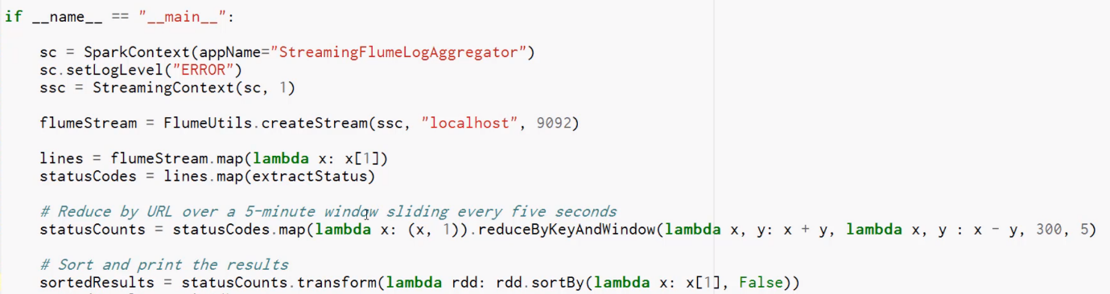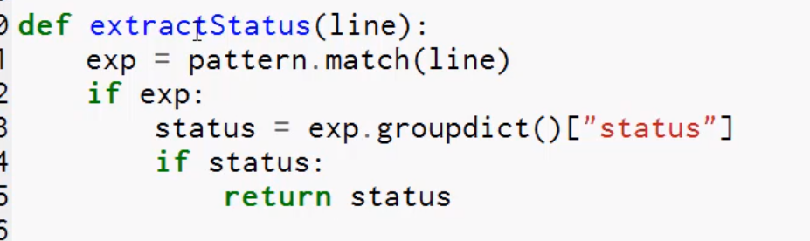

Run it in a console. It will only tick every 5 second

Start flume in another console.

Another console. Copy into the file system. Ensure that you don’t have the same name, spooldir and flume will give you an error.